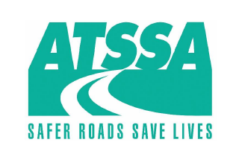

PA ATSSA Chapter

Guiderail Committee Meeting Agenda

July 16, 2025

Agenda Items for Discussion

1. Update on any changes coming to the guiderail standards
2. AASHTO M180 Status
3. Open Discussion